RESOLUTION NO.__________

RE: CERTIFICATE OF APPROPRIATENESS UNDER THE
PROVISIONS OF THE ACT OF THE PENNSYLVANIA
LEGISLATURE 1961, JUNE 13, P.L. 282 (53
SECTION 8004) AND BETHLEHEM ORDINANCE NO.
3952 AS AMENDED.

WHEREAS, it is proposed to repaint the existing front door at
404 High St.

NOW, THEREFORE, BE IT RESOLVED by the Council of the City of Bethlehem that a Certificate of Appropriateness is hereby granted for the proposal.

Sponsored by: (s)

(s)

ADOPTED BY COUNCIL THIS DAY OF 2016.

(s)
President of Council

ATTEST:

(s)
City Clerk

HISTORICAL & ARCHITECTURAL REVIEW BOARD

The applicant is proposing to repaint the existing front door at
404 High St.
APPLICATION #3:

Bruce Sinclair
404 High Street
Bethlehem, PA 18018

OWNER:

__________________________________________________________________________

The Board upon motion by Phil Roeder and seconded by Beth Starbuck adopted the proposal that City Council issue a Certificate of Appropriateness for the following:

- Paint front door with Benjamin Moore Historic color Tarrytown Green.

- Part of door to be of eggshell finish.

3. The motion was unanimously approved.
__________________________________________________________________________

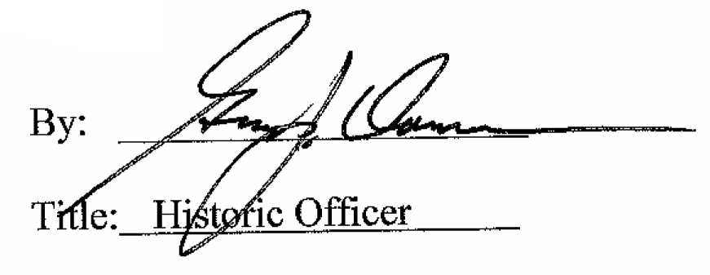

Date of Meeting: October 5, 2016

